St. Matthias Parish

High School
Christian Formation
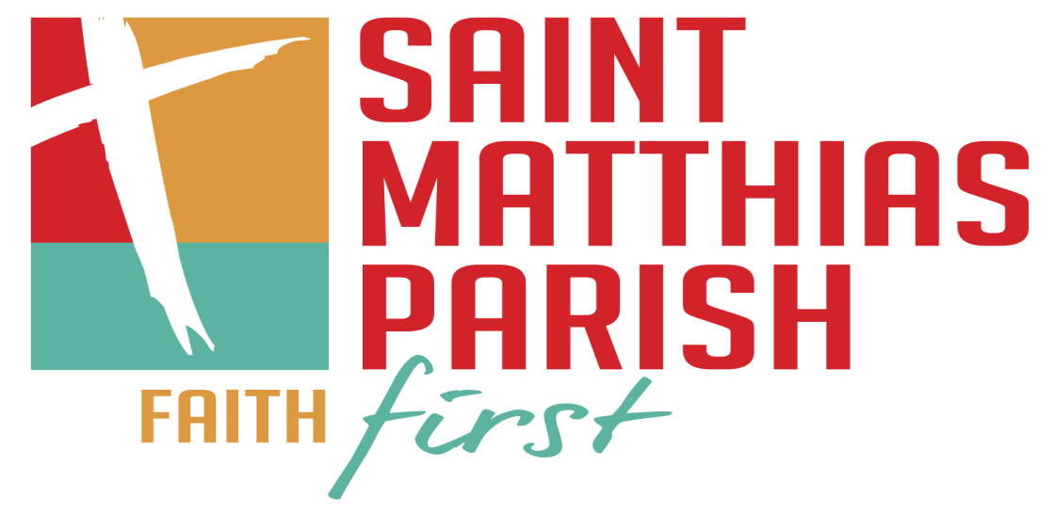

Parent and Youth Handbook
2017-2018

Brian Jens
Director of Lifelong Faith Formation
414-982-2406
bjens@stmatthias-milw.org

Thomas Gallagher
Coordinator of Lifelong Faith Formation
414-321-0893 x405
tgallagher@stmatthias-milw.org

St. Matthias Parish
9306 West Beloit Rd.
Milwaukee, WI 53227
414-321-0893
St. Matthias Mission Statement
St. Matthias Catholic Parish is committed to continuing the ministry of Jesus the Christ. We invite and welcome all, no matter what your race, language or creed; no matter what your orientation or marriage situation, no matter where your journey has led you. Come...live, grow and be challenged by the message, through prayer, formation and service.

Christian Formation Mission Statement

The St. Matthias Christian Formation Program ultimately seeks to provide families, made up of students and their parents/guardians, with the opportunity to develop an intentional relationship with Jesus the Christ whose faith manifests itself in community with the larger church and service to the world.
- Familial Programming
  - How the family practices their faith outside of the class on Sunday’s is what is most important.
- Develop an Intentional Relationship
  - Our catechesis seeks to provide opportunities to develop lifelong skills for both students and parents to practice their faith in a daily way.
- Faith Manifested in Community
  - Families see their full potential by being in communion with their immediate family and then by participation in the community of the Church on Sundays.
- Service to the World
  - Students are gradually introduced to the needs of the world and how they can use their talents to help make the world a better place. Ultimately students will be challenged to take the initiative in giving of their time and effort to fulfill the needs of the world.

High School Christian Formation Program Description

The St. Matthias High School Christian Formation Program is a 3 year program designed to help students become intentional disciples of Jesus Christ who feel empowered to continuously grow in their faith. In the end these students will have received the sacrament of Confirmation, but even more they will receive a foundation for how to live their life of faith with practical lifelong skills they can use in the context of their everyday life.

Curriculum Explained
The curriculum that is used has several components. The first component is the High School Theology Curriculum written by the leadership of the Archdiocese of Milwaukee in concordance with Office of Catechesis and Youth Ministry. This document sets out the objectives for all students in what they should know in areas of Scripture, Creedal and Doctrinal Concepts, Justice and Morality, Liturgy, Sacraments and Prayer, and finally Church History. With that as our basis we then use various resources from St. Mary’s Press such as the Catholic Faith Handbook and Confirmed in a Faithful Community.

With St. Mary’s Press comes multiple activities to help engage the students in applying each lesson to their own lives. More activities are added, adapted, and enhanced to help meet the students where they are at developmentally and spiritually. In essence students will learn to apply their faith while having fun doing it.

Admission Policy

St. Matthias, in its mission to bring everyone closer to Christ, takes its mission seriously by welcoming anyone to be a part of the St. Matthias Christian Formation Program. You do not have to be a parish member to join. That being said, the mission of St. Matthias is also strongly rooted in community. Families that are part of our program are encouraged to be actively involved here at St. Matthias through Mass on weekends and service opportunities around the year.

Program Policies

Attendance

- Classes begin promptly at 6:30pm in Steiger Hall. You must enter through the Handicap Entrance located next to the Parish Office. Classes end at 8:30pm. Please pick up your child(ren) no later than 8:45pm.

- Students are not allowed more than three absences (excused or unexcused). After the student has missed three classes parents will be contacted to inform them. If a student misses more than three classes make-up work will assigned. Make-up work includes the following:
  - Attending a Christians in Action (CIA) Discussion Night – (See attached schedule).
  - Attend an extra District Presentation.
  - Complete two extra hours of service.

- All students at the beginning of the year will be given a binder which will have a notebook for journaling and their service information. The students are to hold onto it for the entire year. It will be the responsibility of the students to bring their journal with them to every class.

- Schedule for all classes are included in this packet. Each grade will have at least two class periods a month. Please check the dates so as to help prevent conflicts. The schedule has been updated with our Confirmation date on it.
  - CHS – Catholic High School Students – if you belong to a Catholic High School and you are in preparation for Confirmation you only need to attend when all 11th grade students meet. This is marked by (CHS).
  - May 20th – Last day of classes will be a closing Mass with all the families from High School Christian Formation. The entire family is invited to partake in this, even those students who already received Confirmation. After Mass there will be displays downstairs of all the work students did throughout the year.

- If you know of a date when your child(ren) will not be able to attend please contact Brian Jens. You can either send an email or leave a voicemail.

- If a session needs to be canceled because of inclement weather, the Director and Coordinator will notify Channel 4, 6, & 12 on TV and their corresponding websites. Also, radio stations AM 620 WTMJ and FM 94 WKTI. An email will be sent out, and it will be posted to the website as well. Please tune into one of these sources.

Notification for cancelling classes will happen no later than 1:00pm Sunday afternoon.

Sacramental Preparation

- Students start immediate preparation for Confirmation in their junior year or 11th grade.
  - Church Policy – all students must have completed at least one year of high school Christian Formation to be eligible to begin immediate preparation of Confirmation.”

- If for whatever reason your child(ren) have not received Baptism, 1st Communion, or 1st Reconciliation please call Brian Jens. Brian will work with families so they can help all students get caught up in their sacramental preparation.

Cell Phones

- Cell phones will no longer be allowed to be used anywhere inside church premises. This means classrooms, church, hallways, or hall!

- Students in grades 9-11 we will be required to put their cell phone in a basket separated by their small groups, and they will label their phone with a posted note to eliminate confusion. Baskets will be monitored by catechists in small group rooms. All students will receive phones when classes have ended at 8:30pm.

- Catechists have the right to take anyone’s cell phone if it is seen during class time. The phone will then be held onto until the end of class.

- Any student unwilling to comply with cell phone policy will result in parents being contacted.

- In cases of emergency where a student must have their cell phone on them a parent must indicate that to Brian Jens prior to the start of class.

Updated 11/1/2017

Transportation

- Students are to arrive no earlier than 6:15 p.m. and leave no later than 8:45 p.m. We cannot guarantee supervision outside of those times.

- If a student is leaving early, they must provide a note from their parents (an email or phone call from the parents earlier in the week will also suffice). We are responsible for all students from 6:30 to 8:30 and will not allow them to leave early without permission from their parents.

- All students driving themselves to class must stay within the building from the moment class starts to when it ends. If students are caught leaving the premises or driving somewhere while class is going on keys will be taken away and parents will be contacted.

Program Requirements

- Attend weekend Masses regularly.

- Attend classes regularly.

Service Component

      - Service and volunteering is an essential aspect of being Catholic. It is one of the many disciplines that we need to develop. Our goal for every student in the Christian Formation program as it pertains to service is:
        - Expose: introduce students to a variety of places to serve, different ways of serving, and different levels of service.
        - Expand: challenging students to start small and expand their comfort zone. Service is be both rewarding and challenging.
        - Educate: applying what we learn on Sunday evenings to what we are doing in our everyday life.
        - Reflect: taking quality time to think about what you did, the impact it made on you and the people you served, and what does the experience mean in the long run.
        - Share (optional): how can the message and purpose of what you did be shared with the world. Students will be challenged to share their experiences in many different formats through in person testimony, in written form, group presentation, etc.

      - Instead of accumulating a certain amount of hours students will collect a certain number of experiences that deal with the different communities they interact with on a regular basis. Students will collect a minimum of 6 different types of experiences. Below are requirements in each of the following categories:
        - Family Community (1): do two different things with 1 or more of your family members.
    - Example: As a family serve food at St. Ben’s Meal Program, go shopping and make a salad for St. Ben’s.
  - School Community (2): Do two different things that impact your school.
    - Examples: activity through a club, tutoring, coaching
  - Parish Community (2): do two different things to impact our parish community
    - Examples: Children’s Liturgy of the Word, coaching, lectoring, server, hospitality minister, setting up decorations for Christmas and Easter, festival
  - Community At Large (1): do two different things that impacts our community at large:
    - Examples: St. Vincent De Paul, St. Ben’s Meal Program

- After each experience the student will be responsible for logging the details of the experience (date, time, # of hours), and completing a reflection for 1 of each type of experience. Service Hour sheet and reflection sheets are located in the student’s binder.
  - The student’s binders will be checked and initialed every class period.
  - It is highly recommended that the students complete their logging and reflection within two weeks of the experience.
  - A single experience could count in two or more different areas only if there are done on separate dates.
  - If a student is doing 2 extra hours of service to make up for missed class time they must clearly indicate this on their service project chart by writing the word “Make-Up” on their sheet.

- The definition of service that we will use is: “The willingness to work for the benefit of those in need without compensation or recognition of any kind.” (The Four Pillars of National Honor Society)
  - If you have any questions about what counts and what doesn’t count as service please contact Brian Jens. In any cases of conflict the Director has the final say.
  - If you are having trouble finding any opportunities please contact Brian Jens for assistance.

- Christians In Action Youth Group – in order to help with providing enough experiences and opportunities to complete your service requirement the parish youth group, Christians In Action, will be doing some form of service at least once a month. At the end of September a Youth Group schedule will be mailed out to all students in the Christian Formation Program which will include dates and times for all of the service opportunities.

- In the case that the student has service requirements in other places (National Honor Society) students made use a single experience to count in both places.

- All service requirements must be completed by the last date in which the group meets. The starting date for counting service will be in the previous summer. The official range of dates are below:
  - 9/10th Grades Service Range: June 1, 2017 – April 29, 2018
  - 11th Grade Service Range: June 1, 2017 – April 15, 2018

- See Page 7 of this handbook to see a sample copy of what the service hours look like.

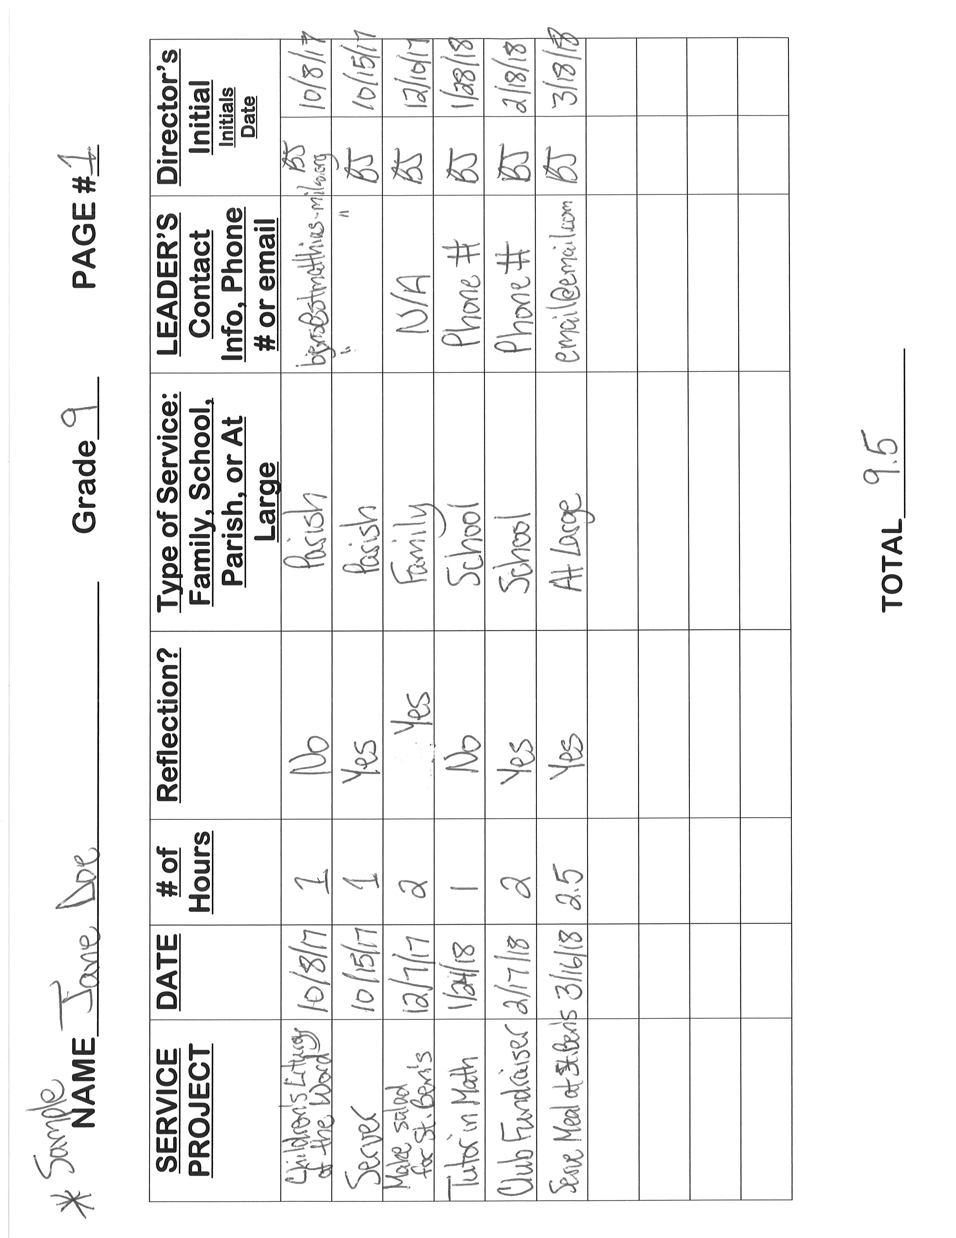
District Presentations – 9 & 10th Grades

- Every student must attend at least one District Presentation a year. Dates and topics are located on the schedule. All presentations will be located at Catholic parishes.

- Flyers for each presentation will be made available about one month in advance.

- When attending you must sign/initial that you attended at the registration table next to the spot labeled St. Matthias.

- Students must attend District Presentation that is scheduled for their own grade. Example: 9th grader cannot attend a Confirmation District Presentation.

- Parents/Guardians are responsible for the transportation to and from the sites in which these presentations take place. If participation in District Presentations is in conflict because of a lack of transportation parents/guardians are asked to inform Brian Jens prior to the date.

Parent/Guardian Formation Opportunities

The family “a community of love and solidarity, which is uniquely suited to teach and transmit cultural, ethical, social, and spiritual and religious values, essential for the development and well-being of its own members and society.” (Charter of the Rights of the Family, Holy See)

- We as a parish are dedicated not only to the formation of the teens, but also to you as parents/guardians in your role as the first educators of the faith of your children. Below are available opportunities for you to engage in faith formation for yourself as well as with your son/daughter.

- Go to Mass:
  - What we teach your children gets reinforced during Mass.
  - It’s what makes us uniquely Catholic.
  - Helps to create a sense of parish community.

- Family Faith Sessions Sunday Evenings – periodically throughout the year there will be designed sessions that incorporate both parents and teens. These are not mandatory but are offered for your benefit throughout the year. Sessions will include a topic as it relates to families and will have breakout group discussions for both parents and students. See the following schedule below:
  - September 10th, 2017 – Purpose of Community – Church of the Home
  - October 1st, 2017 – Family & the Bible
  - November 5th, 2017 – Ritual & Celebration – Celebrating Family Rituals
  - December 3rd, 2017 – Christian Service – Serving As a Family
  - March 4th, 2018 – Reflecting Together – Sharing Faith & Values

- Every week we will send out a Christian Formation Newsletter which will include take home points of things we discussed the weekend before, and will include activities of how to continue to talk about faith at home.

- Get involved at the parish. There are multiple ways you can assist in the Christian Formation Program as well as the parish at large. Opportunities for Christian Formation include:
  - Hall Monitor – monitor areas where students have classes. Sign-Up online
  - Off Site Chaperone – assist Director or Coordinator in events off-site away from St. Matthias such as St. Ben’s Meal Program. Must be Safeguard Trained.
  - Christians In Action (CIA) Youth Group Chaperone – assist in youth group events both at St. Matthias and off-site. Must be Safeguard Trained.

- Adult Faith Formation Opportunities – throughout the year there will be opportunities for parents to get involved in Adult Faith Formation. These will be offered throughout the week. Check the newsletter and bulletin for updates.

- Talk with Brian Jens – as a staff we are always looking to serve our families as best as we can. Contact Brian Jens to set up a talk on the phone or in person so we can get to know you better and how we can best serve your needs as a parent and as a Catholic adult.

Communication

Communication is the cornerstone to keeping the program running smoothly. We have multiple ways of communicating, i.e. phone, email, website, etc.
Please check all these forms of communication at least once a week.

Emails
- The emails you provide us allow us to send you info about the program and upcoming events.

- Newsletters
  - Christian Formation – every Wednesday during the year you will receive a newsletter sent to all of the families within Christian Formation. In this newsletter you will see:
    - Volunteer Sign-ups
    - Easy clickable links to different parts of the St. Matthias website
    - Schedule of the upcoming two weeks
    - Parish Wide Events
  - Advertisements – periodically, depending on what grade your child(ren) you will receive emails for District Presentations, Christians In Action (CIA) Youth Group Events, service opportunities, and general reminders of upcoming deadlines.
  - By hitting reply to any of these newsletters you will be able to reply directly to my email if you should have questions about anything.

- If you leave an email for either Brian Jens you should receive a reply within 24 hours. If you send one during the weekend you may not receive a reply until Monday.

Website
      - The St. Matthias Parish website is loaded with information about what’s happening in the parish.

      - Everything for Christian Formation is located under the “Faith Formation” tab. If you have questions check these places.
        - Sunday Morning Program – info about the program and curriculum info.
        - 9th, 10th, 11th grade Christian Formation – info about the high school program and curriculum info.
        - Christians In Action Youth Group – upcoming events, permission slips, and more.
        - Formation Forms – printable schedules, service forms, handbooks, and parent forms.

Procedure for Communication
- In order to provide everyone with the best possible program Brian and Tom rely on the communication of the families to ask questions, express their concerns, or talk with someone if need be.

- Chain of communication is dependent on the day and time of which you have a question:
  - Sunday
    - Catechist – in person
    - Director/Coordinator – in person
  - Monday – Friday – 8:00am – 4:00pm
    - Director/Coordinator – phone or email
  - Monday – Friday – after 4:00pm
    - Website
    - Director/Coordinator – phone or email
  - Saturday
    - Website
    - Director/Coordinator – phone or email
      - Probably won’t answer until Monday

- If you have a question about or concern about your child(ren)’s catechist please talk to them first. If you are uncomfortable to approach them you may call Brian Jens to set up a conference with all 3 parties.

- If you have any questions or concerns about the program in general call Brian Jens during office hours to discuss, or email us to set-up an appointment.

- Contact Info
  - Brian Jens – Director of Lifelong Faith Formation – can be reached at during the day at 414-321-0893 x406 or after hours at 414-982-2406
  - Office hours are Monday – Friday 8am-4pm.

Behavioral Expectations

It Starts and Ends with R-E-S-P-E-C-T
- All students are expected to have a level of respect that is appropriate for their age.

- Respect The Building/Church
  - Students will be respectful of the buildings in which they are in class.
  - Students will demonstrate awareness of the place and situation they are in.
  - Students will not deface, damage, or destroy any property of St. Matthias. Families will be responsible for any costs that are incurred.
  - Students will be extra respectful and reverent while in church.

- Respect for Catechists/Director & Coordinator
  - Students will display a high level of respect for their catechists and the Director/Coordinator.
  - Students will demonstrate good listening skills by listening to the catechists and following directions when asked.

- Respect for Each Other
  - Students will display a high level of respect for their peers.
  - Students will demonstrate good listening skills by give full attention to what their peers share no matter if they agree or disagree.
  - Students will show respect for each person’s background (where they come from, who they are as people, and where they are on their faith journey).

Procedure for Breaking of Rules
- Any forms of misbehavior or disrespect will be addressed immediately.

- If a student continues to have behavioral issues parents will be called the day after class to be made aware of their son/daughter’s behavior.

- If a problem persists after contacting parents/guardians will called immediately, and will be asked to speak with Director/Coordinator and student after class to discuss behavior. Parent will attend the following class with their son/daughter.

- If a parent/guardian disagrees with any action taken by the Director they may contact Jeff Van Dalen, Parish Director, to discuss the situation.

Drugs and Weapons Policy
- Drugs, alcohol, smoking and any drug paraphernalia are not allowed. If any youth is found with any of these substances the parents will be called immediately, and student will be expelled from the program.

- We hold a zero tolerance policy for weapons of any kind. Because Steiger Hall also serves as a building for the school, if a youth is found with a weapon, in addition to the parents being called the Milwaukee Police Department will also be called immediately.

Parents/Guardians We Need You!
Parents/Guardians we are asking for your support when it comes to respect and behavior. We are here to support you just as much as we are here to support your children. You are asked to contact Brian or Tom if you have any worries, concerns, or feedback you have.

Off-Site Activities

District Presentations – See Above under Program Policies Program Requirements

Christians In Action (CIA) Youth Group
- For those people who don’t know CIA is St. Matthias Parish Youth Group. A youth group is a community based group comprised of high school students of St. Matthias. These students meet in order to share fellowship, serve others in special ways, and most importantly create a presence for youth in the parish.

- The importance a youth group is that it creates another community that teens of this parish can be a part of. As youth are looking to find ways to fit in with peers this youth group offers a unique opportunity to all youth looking to create new friendships and be a part of a community of people who share similar values.

- There is absolutely no commitment to participate in all activities. You may come and go to meetings whenever you are available.

- Also, the group is open to all high school students, not just parish members. So, if you would like to bring a friend you are more than welcome to do so. Pairing up with someone you know to come together is a great way to feel comfortable in a new situation.

- Students who attend CIA sponsored events will be held to the same respect rules and consequences as students in Christian Formation.

- The schedule including times and dates for all CIA Youth Group will be mailed out to all families in Christian Formation.

CYM Sports – Sports league designed for high school students who don’t play at the high school level. For more information please go to the website: www.cymsports.com
- Students who are in the High School Christian Formation Program are eligible and encouraged to participate in these seasonal sports. Such opportunities give students a chance to build community while displaying sportsmanship and gospel values.

- Students of the program are the ones in charge of initiating interest in creating a team under the direction and guidance of parents/guardians. Students then can create a team following the rules set out by the CYM Sports organization. Once a team is formed contact the Director of Lifelong Faith Formation.

- These rules below are to be followed by all students participating in CYM Sports.
  - As stated by the Archdiocese of Milwaukee CYM Volleyball/Basketball Handbook:
An individual's participation in a parish-based team requires:
  - 1. A parent/guardian must be registered members of the parish.
  - 2. The student must: Attend parish religious education classes regularly or attend a Catholic High School.
  - 3. When possible, it is recommended that seniors participate in a religious education program designed for seniors. When a senior program is not offered, seniors must have completed requirements for the Confirmation Program.
- Archdiocesan policy states that:
  - b. There is to be NO practice or competition during the hours the involved student's parish religious education or youth ministry activities are in session.
  - Additionally students are required in the registration process to provide times/dates of classes and time of Confirmation Retreat.

- Anybody found falsifying information or not following these rules will have the League Director contacted by the Director of Lifelong Faith Formation with consequences coming from the League Director.

- Attendance for all high school students in Christian Formation is a prerequisite to participating in CYM. Therefore, anybody who misses 4 classes or more will be deemed ineligible to play any CYM sport for the current school year.

- Any special circumstances that present themselves will be taken on a case by case basis. In all cases the Pastor/Parish Director has the final say.

Use of Parish Grounds and Facilities

Buildings in Use
- The High School Christian Formation Program utilizes a number of the buildings on the St. Matthias campus including St. Matthias Church, Steiger Hall, Parish Office, Parish Center, and the 62 Building.

- Some students will have to go outside in order to reach the place where there class is taking place. At such time students are expected to stay with their given small group at all times. Small groups will be divided on first day of class.

- Any student caught wandering the St. Matthias campus in places other than spots used for class will have their parents called after class.

Safeguarding All God’s Family

Classes Required by Archdiocese
- To assist in self-awareness of issues regarding sexual abuse the Archdiocese of Milwaukee requires us to do a lesson with each grade appropriate for their age level. When class takes place you will receive advanced noticed of at least two weeks prior with a letter that will be sent home.
- The letter will indicate the time, place, and what will be covered in the lesson. Parents are strongly encouraged to attend with their child. A parent may also choose to opt out of the class. If that is the direction the parent wishes to take they must indicate that prior to class, and will have to give a signature verifying their decision.

We have read and agree to be governed by all policies stated in this handbook.

Detach this sheet and hand it in to Catechist before start of 1st Class.

Student Signature Date Grade

_____________________________________________________________________________________

Student Signature Date Grade

_____________________________________________________________________________________

Student Signature Date Grade

_____________________________________________________________________________________

Student Signature Date Grade

_____________________________________________________________________________________

Student Signature Date Grade

_____________________________________________________________________________________

Student Signature Date Grade

_____________________________________________________________________________________

Parent Signature Date

_____________________________________________________________________________________

